My Favorite Essential Oils for Athletes
OnGuard – protects against viral and bacterial assaults, immune boost
Lemongrass – relieves tight muscles, stiffness
AromaTouch – relieve achy muscles, spasms – use with lemongrass
Breathe – increase breathing capability and relieve congestion
Lavender or Serenity – calming blends to soothe nerves
Deep Blue – muscle aches, similar to icy hot
Ginger – digestion and nausea relief
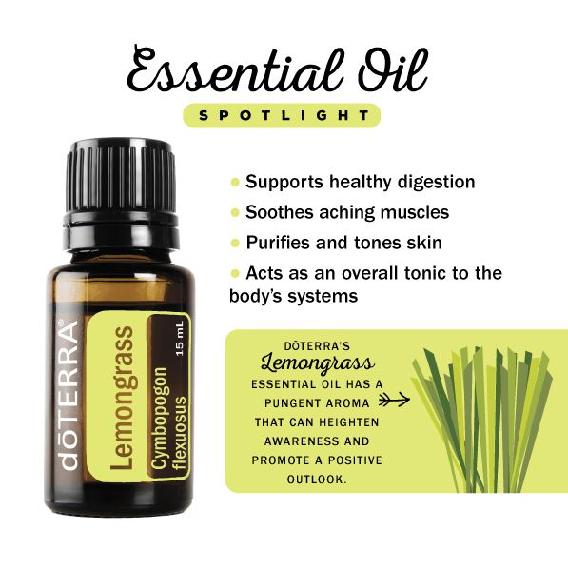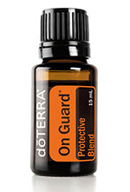
Breathe® is a remarkable blend of essential oils that help you breathe easier. This proprietary blend cleanses and soothes the airways.
On Guard®
is formulated to support healthy immune function. A natural and effective alternative to synthetic options for immune support.

AromaTouch®
is a massage blend to relax muscles, calm tension, soothe irritated tissue, increase circulation, smooth and tone.
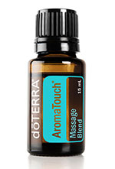
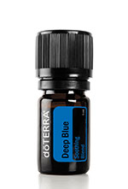
Deep Blue® is a soothing solution to pain. It works to ease achy joints and sore muscles. Its effects are deep and penetrating results.
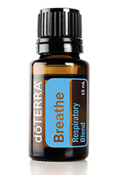

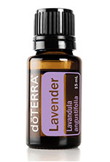
Application: Aromatic (diffuser), Topical (on skin)
Visit www.mydoterra.com/joannachodorowska
Or call 215-272-6774 to schedule your private
session to pick which oils may be right for you.
Lavender is widely used and accepted for its calming and relaxing qualities.

